CLIMATE CHANGE ADAPTATION

A manual for trainers

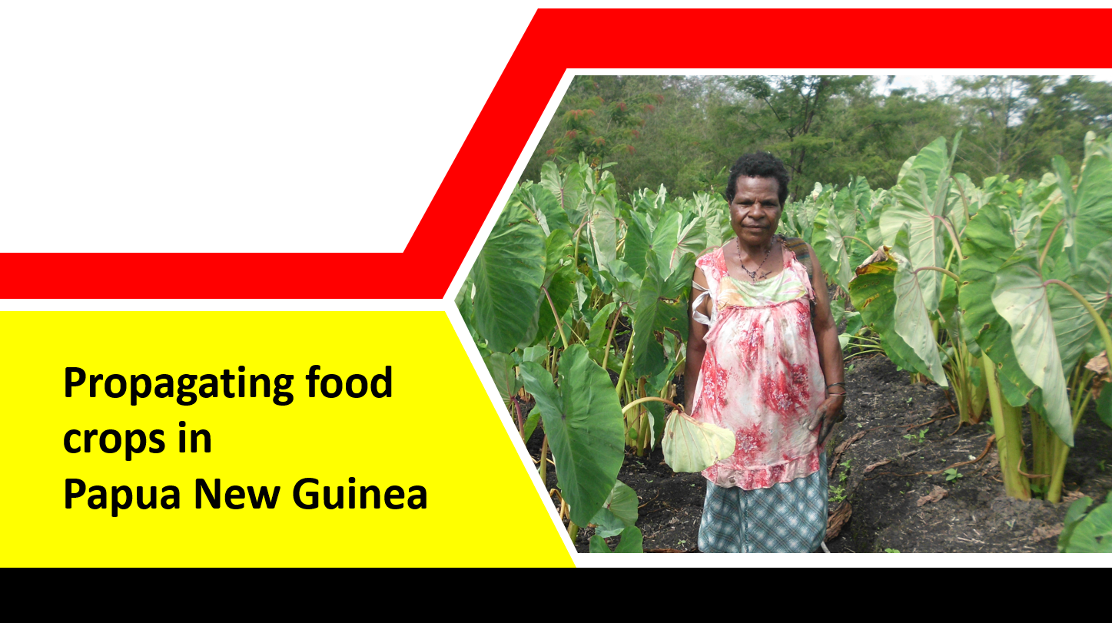

|  |  |
| --- | --- |
|  |  |

Supported by the European Union

**Jeffrey Waki and Cyril Kolese Atung**

**Acknowledgements**

**NARI gratefully acknowledges the generous support of the people of the European Union in the Action - Strengthening food production capacity and the resilience to drought of vulnerable communities.**

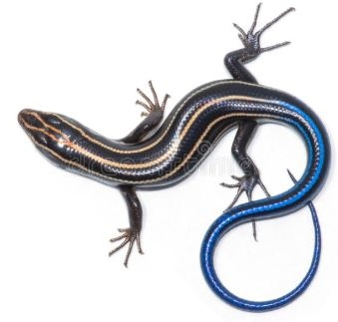

**Table of Contents**

Introduction 1

Session 1 – Types of seed materials and their Propagation 3

Materials and methods 3

Session 2: Yam mini-sett and field planting 5

Materials and methods 6

Yam Propagation 7

Recap of session 10

Reference Handouts 10

Session 3: Taro propagation and field planting 11

Materials and methods 12

Photos showing taro mini-sett preparation 13

Detailed description of Taro mini-setts 14

Recap of session 15

Reference Handout 15

Session 4: Banana bit and field planting 16

Materials and methods 17

Propagation of Bananas 17

Recap of session 20

Reference 20

Session 5: Cassava mini-stem cutting and field planting 21

Materials and methods 21

Cassava Propagation 22

What is a Cassava mini stem? 22

Recap of session 23

Reference 23

Session 6: Sweet potato nodal cutting and field planting 24

Sweet potato Propagation 25

Recap of session 26

Reference 26

Concluding remarks 26

|  |
| --- |
| Please don’t start a training without reading –  Training villagers in PNG**!**  **You can download a copy here-**  [**http://gutpela-png-gaden.net/library/record/view/id/43**](http://gutpela-png-gaden.net/library/record/view/id/43)  **Muntwiler and Askin, 2004. Training villagers in PNG - a manual for trainers.**  **Remember, training is much more than giving technical information. The Muntwiler and Askin manual will provide lots of useful information to assist the process of your training**. |

# Introduction

Root tuber and banana (RTB) are crops considered as staples in PNG. Apart from banana, root tubers include sweet potato, yam, cassava, taro true and chinese taro. RTBs are normally planted from vines, tubers, stem cuttings, suckers and headsets, which are all collectively referred to as seed stocks. The seeds of next planting season or cycle are usually derived from previous cropping following a single harvest or after series of harvests have been completed.

While this is much appreciated, the continuous practice of collecting planting materials directly from old gardens and re-planting is seen as important route for transmitting pests and diseases, resulting in cultivar degradation (yield decline) over time. Moreover, this has also limited access to obtaining maximum quality and increased number of planting materials to plant new gardens and also for distribution within and outside the village. The commercial changes also demand the supply of quality and huge volumes of seeds.

Climate change poses great challenge for adaptive agriculture. Drought events like that which was experienced in 1997 and recently in 2015-16 is predicted to continue recurring with high intensity and has caused devastation throughout the PNG country. Such experience requires simple but relevant technologies that are important for safeguarding the wellbeing of vulnerable farming households against climate calamities.

This manual is prepared to expand the knowledge base of Trainers regarding improved seed production techniques. These include rapid field multiplication of quality planting materials of RTBs, particularly, sweet potato, taro, yam and cassava. The overall goal is to build capacity of farmers/trainers to be climate smart and resilient in the face of difficult times.

### Preliminaries: Getting to know each other

Farmers have diverse experiences and exposure in practically applying crop farming practices. They attend trainings with diverse farming backgrounds. Farmers may feel timid and uneasy when coming together to participate in trainings. Since any training session normally require full participation from trainees whether in theory or practice it is important that farmers get to know each other before the actual training sessions begin. This put all of them together in a learning environment.

To achieve this goal the following activities can be done:

|  |  |
| --- | --- |
|  | Working together  * Ask farmers to introduce themselves. * Have them give their location and talk about their experiences with their gardens. * Discuss together how many different crop types do they grow? * How do they select and prepare materials for planting new gardens? * What plant parts are normally used for planting? * When do they normally harvest planting materials for next planting? * Do they consciously prepare seed beds for raising planting materials? * Are they concerned about diseases or insect pests that might come with new planting material for their gardens? * Do they apply minimum cleaning to materials before planting? * Have any of the participants received training on crop production covering some of the questions posed above? |

|  |  |  |
| --- | --- | --- |
|  | Farmers will 🡪  * Appreciate the importance of cleaning seed materials. * Appreciate the purpose of rapid multiplication of planting materials especially when drought happens. | |
|  | |

# Session 1 – Types of seed materials and their Propagation

Plant seed refers to the part of a plant that is used to produce the same kind of species in subsequent generation. It can refer to true botanical seed or vegetative parts. e.g. corns seed, taro suckers and cassava cuttings. Without seeds species gradually dye out and become extinct.

|  |  |
| --- | --- |
|  | Farmers will 🡪  * Learn to categorize crops into their different mode of propagation. * Understand the importance of maintaining and planting clean or healthy seed stocks |

## Materials and methods

**Target Participants:** Crop farmers, extension service providers, school students, community organizations/institutions

**Suggested Number of Participants:** A maximum of 30 persons

**Duration:** 40 minutes.

|  |  |
| --- | --- |
|  | Materials required  * Flip chart and masking tape or whiteboard * marker pens * white board markers * notebooks and pens and hand outs |
|  | Working together  * Write the title “Crops in your village –how they propagate” on the whiteboard or flip chart. * Engage each participant to do a list of 5 most important crops in their households. * Explain what a seed is, and, its importance. * Allocate the participants in 5 groups and assign them the following tasks: |
|  | Tasks  * Collate individual group member’s crop list into one removing the repeating ones. * Base on their experience, ask the participants to identify the crops by their mode of propagation, as either (a) true-seeded, (b) vegetative (vines, stem, tuber) and (c) both seeded and vegetative. * Ask the participants to discuss how and when seeds/seed stock are collected and prepared for planting * Ask the participants to brainstorm on how seed/seeds stock cleaning is done for all or any of the crops before next planting cycle. * Demonstrate how seeds/seedstock are derived from mother plants (refer to Handouts). * Demonstrate how seeds/seedstock are cleaned before planting new gardens (Refer to Handouts).  Let the participants raise questions and queries, clarify, and conclude the session |

# 

# Session 2: Yam mini-sett and field planting



Yam is a staple crop in Papua New Guinea with cultural values. Among traditional yams, rotundata (or Africa) yam has been recently introduced and gaining popularity. Yam is cultivated from tubers alone following a brief dormancy period of at least two months.

Yams can be multiplied using a *mini set* technique. A mini-set is a small piece of yam cut from a tuber (mother seed yam) which is prepared specifically for production of planting materials.

|  |  |
| --- | --- |
|  | Farmers will 🡪  * Prepare, * sprout and field plant yam mini-sets |

## Materials and methods

**Target Participants:** Farmers, rural development officers, extension service providers, school students, and community/Faith-based organizations/institutions

**Suggested Number of Participants:** A maximum of 30 persons

**Duration:** 15 minutes.

|  |  |
| --- | --- |
|  | Materials required  * Yam tuber (at sprouting stage), * wood ash, kitchen knife, * spade, sawdust (or cutgrass), * polythene sheet (optional), * watering can, * dry shed, loam soil (or soil mixture of topsoil, sand and manure), handouts. |
|  | Thinking together  * Lecture, * field demonstration, * discussions |
|  | Working together  * Write on the white board/flip chart or simply say the title “How to do a yam minisett” * Discuss how yams are normally propagated * Explain what yam mini-set is, and its usefulness * Demonstrate how to prepare a yam mini-set * Demonstrate how to sprout a yam mini-set in a nursery bed and a wooden box * Demonstrate how to field plant a sprouted yam mini-set * Let the participants raise questions and queries, clarify, and conclude the session |

## Yam Propagation

Yams are vegetatively propagated from tubers and bulbils. Some species have also been able to be produced from vine cuttings. Headsets derived from tubers are predominantly used for planting new gardens following a brief dormancy period of at least two months. Yams are planted into gardens as soon as buds form on the tubers.

|  |  |  |  |
| --- | --- | --- | --- |
| **No.** | **Yam Species** | **Common name** | **Propagation method** |
| 1 | *Dioscorea alata* | Greater yam | Head set |
| 2 | *Dioscorea nummularia* | Pacific yam | Head set |
| 3 | *Dioscorea esculenta* |  | Head set |
| 4 | *Dioscorea bulbifera* |  | Head set, bulbils |
| 5 | *Dioscorea pentaphylla* |  | Head set |
| 6 | *Dioscorea rotundata* | African yam | Head set |

|  |  |
| --- | --- |
|  |  |
|  |  |

|  |
| --- |
|  |

## Recap of session

The participants are given the opportunity to ask further questions and discuss what has been delivered in the session.

* You, the trainer make sure that women and men share information together.
* Listen carefully to people’s experiences – you are learning together.
* The facilitator makes further clarifications and ends the session.

## Reference Handouts

* LAL 003(E).Yam Mini-set Information

# 

# Session 3: Taro propagation and field planting

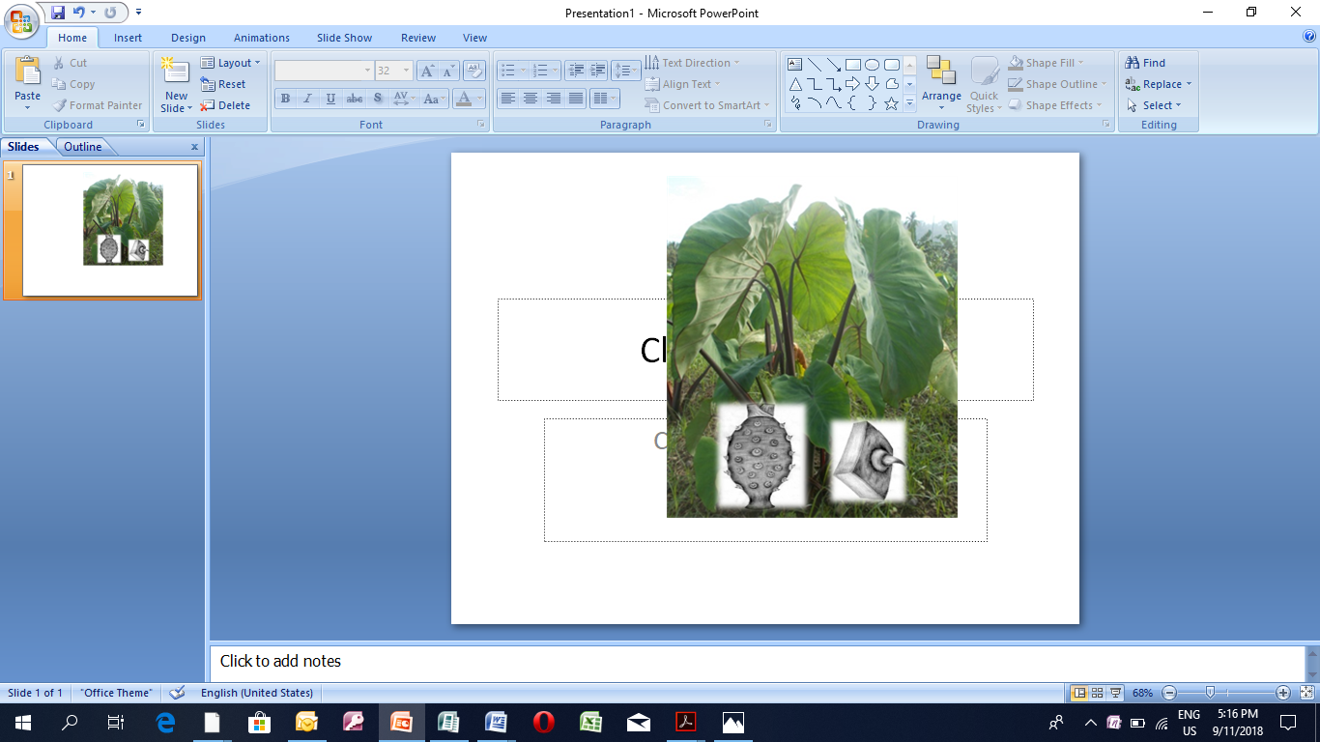

Taro is an important staple in the wet-lowland areas of Papua New Guinea. The crop is cultivated vegetatively using head corms, suckers, stolons. Taro can be fast-propagated on the field using mini-set technique. Taro mini-setts are cut pieces of taro corm, or the underground part of taro that has buds or eyes.

|  |  |
| --- | --- |
|  | Farmers will 🡪  * Be able to prepare, * sprout and field plant a taro mini-set. |

## Materials and methods

**Target Participants:** Farmers, rural development officers, extension service providers, school students, and community/Faith-based organizations/institutions

**Suggested Number of Participants:** A maximum of 30 persons

**Duration:** 15 minutes.

|  |  |
| --- | --- |
|  | Materials required  * Taro corm (mature), wood ash, kitchen knife, spade, sawdust (or cutgrass), polythene sheet (optional), * Watering can, dry shed, loam soil (or soil mixture of topsoil, sand and manure), handouts. |
|  | Working together  * Write on the white board/flip chart or simply say the title “How to do a taro minisett”. * Discuss how taros are normally propagated * Explain what taro mini-set is, and its usefulness * Demonstrate how to prepare a taro mini-set * Demonstrate how to sprout a taro mini-set in a nursery bed, a wooden box and polybags * Demonstrate how to field plant a sprouted taro mini-set * Let the participants raise questions and queries, clarify, and conclude the session. |

## Photos showing taro mini-sett preparation

|  |  |
| --- | --- |
|  |  |
|  |  |

## Detailed description of Taro mini-setts

|  |  |
| --- | --- |
|  |  |
|  |  |
|  | |

## Recap of session

The participants are given the opportunity to ask further questions and discuss what has been delivered in the session. The facilitator makes further clarifications and ends the session.

## Reference Handout

* LAL 002(E). Taro Mini-sett Information
* Bub026. NARI TOKTOK: Best Practice Note for Taro Farmers

# Session 4: Banana bit and field planting

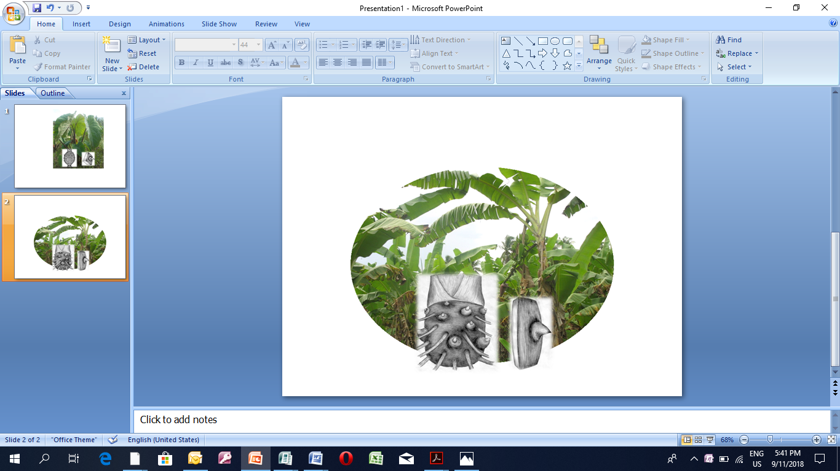

Banana is the second most important staple crop in PNG. Propagation is done by suckers. Bananas can be rapidly multiplied in the field using the banana bit techniques. Banana bits are pieces of corm, or the underground part that has roots and buds or eyes.

|  |  |
| --- | --- |
|  | Farmers will Be able to prepare,  sprout and field plant banana bits.  Know that diseases are causing problems in PNG. Farmers must be careful when they move bananas from one place to another. |

## Materials and methods

**Target Participants:** Farmers, rural development officers, extension service providers, school students, and community/Faith-based organizations/institutions

**Suggested Number of Participants:** A maximum of 30 persons

**Duration:** 15 minutes.

|  |  |
| --- | --- |
|  | Materials required  * Corm of fully grown banana plant (just before flowering), * wood ash, kitchen knife, spade, sawdust (or cutgrass), * polythene sheet (optional), * Watering can, dry shed, loam soil (or soil mixture of topsoil, sand and manure), handouts. |
|  | Working together  * Write on the white board/flip chart or simply say the title “How to do a banana bit”. * Discuss how bananas are normally propagated * Explain what banana bit is and its usefulness * Demonstrate how to prepare a banana bit * Demonstrate how to sprout a banana bit in a nursery bed, a wooden box and polybags * Demonstrate how to field plant a sprouted banana bit * Let the participants raise questions and queries, clarify, and conclude the session |

## Propagation of Bananas

Bananas are vegetatively propagated from suckers. These seed/planting materials are produced from underground stem which are normally referred to as corm. The corms carry mature eyes or buds which initially grow out as rhizomes, emerge as peeper and then suckers (offshoot of parent plant/corm). Sword suckers have better growth potential as compared to broad leaf and water suckers.

|  |
| --- |
|  |
| Suckers at different vegetative stages and the distinct sucker types |

|  |  |
| --- | --- |
|  |  |
|  | Plant the banana bits into small holes and cover with moist soil. |
|  | |

## Recap of session

The participants are given the opportunity to ask further questions and discuss what has been delivered in the session. The facilitator makes further clarifications and ends the session.

## Reference

LAL 001 E - Banana Bit Information.

# 

# Session 5: Cassava mini-stem cutting and field planting

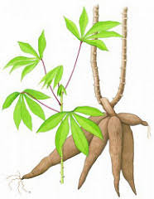

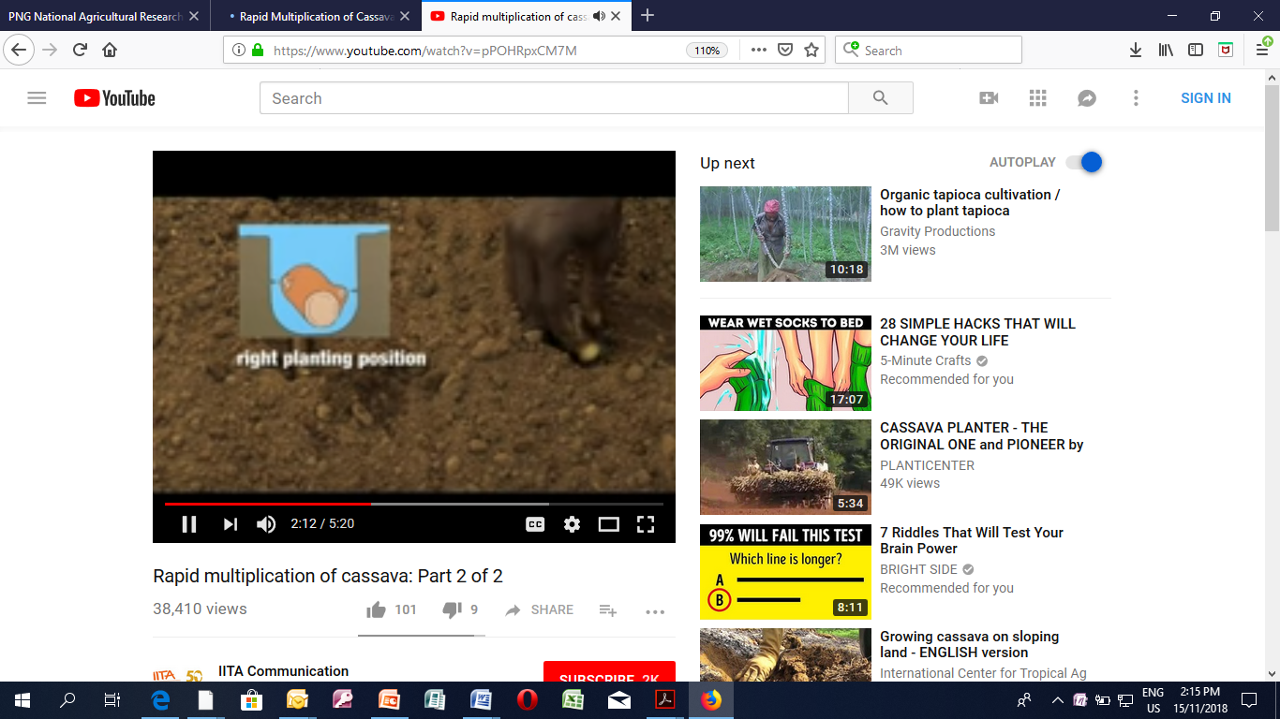

Cassava is normally propagated from stem cuttings. A 90 cm long single stem with 80–100 intact nodes will normally produce 3 plants, each 30 cm long with the conventional method. The rate of getting new planting materials is very low with this approach. Planting materials can be rapidly multiplied using a mini-stem technique. The mini-stem technique uses small stem pieces, which means that a single cassava stem will yield more planting material than the conventional method. For example, 90 cm stem will produce 40-50 two-node cuttings or 20-25 four-node cuttings with the mini-stem technique.

|  |  |
| --- | --- |
|  | Farmers will 🡪  * Participants will be able to prepare, * sprout and field plant cassava mini-stem cuttings |

## Materials and methods

**Target Participants:** Farmers, rural development officers, extension service providers, school students, community/Faith-based organizations/institutions

**Suggested Number of Participants:** A maximum of 30 persons

**Duration:** 15 minutes.

|  |  |
| --- | --- |
|  | Materials required  * Stem of mature cassava plant, secateur or hand saw, spade, sawdust (or cutgrass), polythene sheet (optional), * watering can, loam soil (or soil mixture of topsoil, sand and manure), handouts. |
|  | Making cassava mini stems  * Discuss how cassava is normally propagated * Explain what cassava mini stem is, and its usefulness. * Demonstrate how to prepare and sprout a cassava mini stem in a nursery bed and unperforated polythene bags (clear) * Demonstrate how to field plant a sprouted cassava mini stem * Let the participants raise questions and queries, clarify, and conclude the session. |

## Cassava Propagation

Cassava is normally propagated from stem cuttings. A 90 cm long single stem with 80–100 intact nodes will normally produce 3 plants, each 30 cm long with the conventional method. The rate of getting new planting materials is very low with this approach. Planting materials can be rapidly multiplied using a mini-stem technique. The mini-stem technique uses small stem pieces, which means that a single cassava stem will yield more planting material than the conventional method. For example, 90 cm stem will produce 40-50 two-node cuttings or 20-25 four-node cuttings with the mini-stem technique.

## What is a Cassava mini stem?

Cassava mini-stem is a small stem piece having 2-4 nodes which is primarily used to produce more planting materials.

**Preparation of mini-stem and sprouting of mini-stem**

|  |  |
| --- | --- |
|  |  |
| 1. Select healthy cassava stems. (Left). too young (Mid). woody/old. (Right). softwood/right stage | 2. Cut as many 2-4 node stem pieces or mini-stems including the shoot (10-15cm long) |
|  |  |
| 3. Sterilize the mini-stems in 10 % bleach (for 5 minutes and briefly rinse in clean water. And further decontaminate in insecticide solution (ratio 1ml insecticide into 1 litre water) | 4. (a) Sprout the mini-stem in well drained nursery bed 200 cm long and 15-20 cm high. Make furrows and place cassava mini-setts side at 10cm x 10cm spacing |
|  | 5. Gently uproot the mini-stems and transplant into field |
| 4. (b) Sprout the mini-stem in a clear polythene (plastic). The shoots will form between 2-4 weeks. |  |

## Recap of session

The participants are given the opportunity to ask further questions and discuss what has been delivered in the session. The facilitator makes further clarifications and ends the session.

## Reference

Commercial Cassava Production: Technical Bulletin. Issue 5/ 2011. [www.cardi.org](http://www.cardi.org)

# Session 6: Sweet potato nodal cutting and field planting

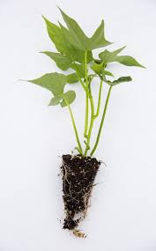

New sweet potato plants are normally raised from vine cuttings and tuber sprouts. They serve as initial materials to start the process of multiplication in nursery.

|  |  |
| --- | --- |
|  | Farmers will 🡪  * Be able to prepare, * sprout and field plant a sweet potato tuber and vine cuttings |

Materials and methods

**Target Participants:** Crop farmers, extension service providers, school students, community organizations/institutions

**Suggested Number of Participants:** A maximum of 30 persons

**Duration:** 15 minutes

|  |  |
| --- | --- |
|  | Materials required  * Sweet potato vines, * Sweet potato tubers * Kitchen knife, spade, polythene sheet * Watering can, mulch (grass cut), loam soil (or soil mixture of topsoil, * Sand and manure), handouts |
|  | Working together  * Write on the white board/flip chart or simply say the title “How to do sweet potato nodal and tuber propagation”. * Discuss how sweet potato is normally propagated * Explain what sweet potato nodal and tuber propagation is, and its usefulness * Demonstrate how to prepare a sweet potato nodal cutting and tuber * Demonstrate how to sprout a sweet potato nodal cutting and tuber in a nursery bed and polythene nursery bags (black) * Demonstrate when to harvest and field plant sprouted sweet potato vines   Let the participants raise questions and queries, clarify, and conclude the session |

## Sweet potato Propagation

**Tuber sprouting and multiplication**

* Select a mature tuber
* Wash and rinse in water
* Sterilize in 10% bleach solution and final rinse in water
* Place into polypot, nursery bag or nurser bed away from direct sunlight
* Mulch with grass or dry leaves.
* Water twice daily to sprouting. It may take 2-4weeks to sprout and continue produce vines.
* Vines can be plucked out and planted into field or further multiplied in the nursery.

**Vine sprouting and multiplication**

* Select healthy looking vines from the field or from sprouted tubers. The vine should continue producing flag leaves.
* Cut a piece using a pair of scissors or sharp knife into 2-node without detaching the leaves. Shoot tip should be reserved with a fully opened leaf.
* Sterilise the cuttings in 10% bleach for 2-3 minutes and rinse in water.
* Plant into prepared bed or nursery trays with a node into the soil.
* Water twice daily to sprouting. It may take 2-4weeks to sprout and continue produce vines.

## Recap of session

The participants are given the opportunity to ask further questions and discuss what has been delivered in the session. The facilitator makes further clarifications and ends the session.

## Reference

## Concluding remarks

.......................................................................................................................................................................................................................................................................................................................................................................................................................................................................................................................................................................................................................................................................................................................................................................................................................................................................................................................................................................................................................................................................................................................................................................................................................................................................................................................................................................................................................................................................................................................................................................................................................................................................................................................................................................................................................................................................................................................